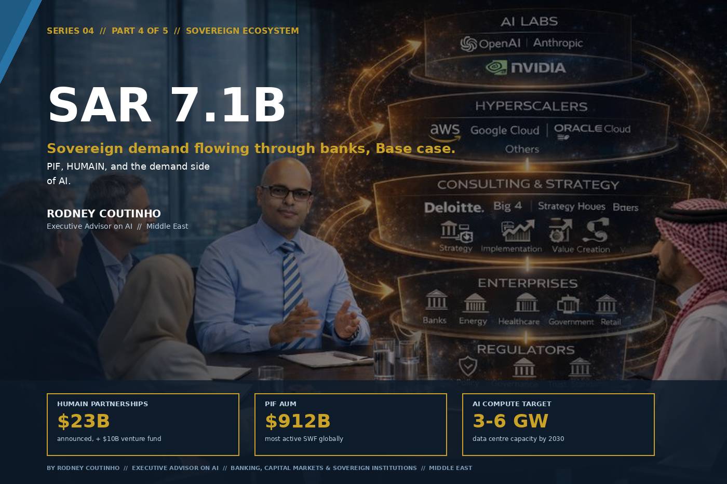

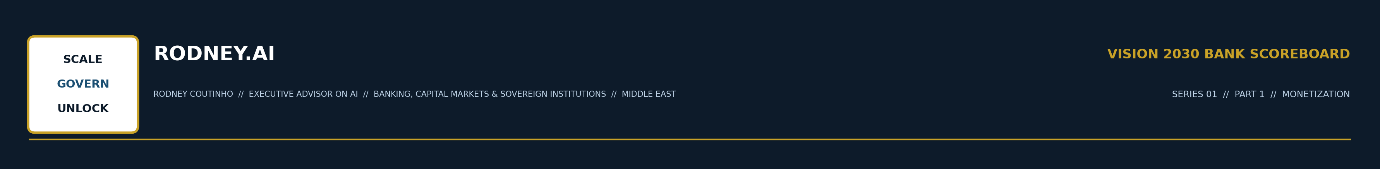
SERIES 04 // THE VISION 2030 BANK SCOREBOARD // PART 4 OF 5 // SOVEREIGN ECOSYSTEM
PIF, HUMAIN, and the Demand Side of AI
By Rodney Coutinho
Executive Advisor on AI // Banking, Capital Markets & Sovereign Institutions // Middle East
Parts 1 through 3 of this series sized levers that banks control: fee pools, tokenised instruments, balance sheet efficiency. Part 4 is different. This lever is not pulled by banks. It is pulled by the sovereign — and it may be the most powerful of the four.
Sovereign Ecosystem. PIF. HUMAIN. The SAR 7.1B lever where the government creates the demand.
THE LEVER
SAR 7.1 Billion
of banking revenue per year, in the Base case. Not from new products or new customers — from sovereign AI spending that flows through the banking system as project finance, trade finance, treasury, and custody.
Low: SAR 2.7B // High: SAR 13.7B // Source: KSA Scoreboard Model

THE SOVEREIGN AI BUILD // UNPRECEDENTED IN SCALE
HUMAIN: the full-stack play.
HUMAIN has announced $23 billion in strategic technology partnerships and a $10 billion venture fund. It has secured 211 plots of land for data centres across the Kingdom, with construction underway on two large campuses comprising 11 data centres, each at 200 MW capacity. A joint venture with AMD and Cisco targets 100 MW of phase 1 deployment. HUMAIN invested $3 billion in xAI’s Series E and signed a joint commitment to build 500+ MW of next-generation AI compute. Aramco has signed a term sheet to acquire a significant minority stake. This is a sovereign-industrial complex being assembled at speed.
PIF: redirecting the portfolio toward AI.
The PIF 2026–2030 strategy explicitly pivots toward AI, technology, and digital infrastructure. PIF assets under management reached $912 billion in 2024. The fund has restructured into three portfolios: Vision, Strategic, and Financial. AI infrastructure is a named priority. Saudi Arabia’s economy minister stated publicly: “We’re reprioritising toward sectors that need it the most, and today it’s technology, artificial intelligence.”

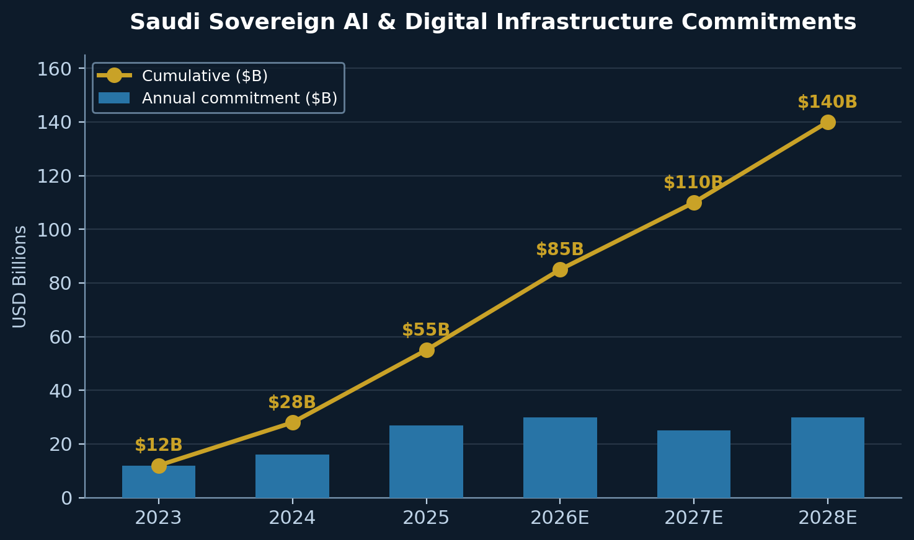

The data centre arms race.
Beyond HUMAIN, Saudi Arabia awarded a $2.7 billion contract for the 480 MW Hexagon data centre in Riyadh. Microsoft has committed an estimated $2.2 billion over five years. Google signed a $10 billion partnership with HUMAIN. The Kingdom’s ambition is 3–6 GW of AI compute capacity, where each gigawatt requires $30–50 billion in investment. The UAE launched MGX, a $100 billion AI infrastructure fund. The two Gulf states are in a regional race to become the sovereign AI hub.

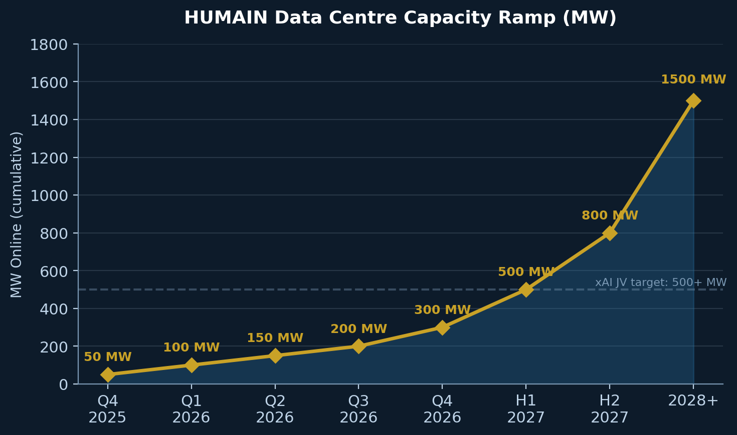

Saudi Arabia has committed over $100 billion to AI and digital infrastructure since 2023. 2026 is the Year of AI. None of this spending sits in a bank’s P&L — but all of it flows through banks.

HOW SOVEREIGN SPENDING // BECOMES BANKING REVENUE
The sovereign AI build creates banking demand through five channels.
Channel 1: Project finance and construction lending.
NEOM alone has drawn SAR 10 billion in revolving credit facilities from Saudi banks, plus $3 billion in SACE-guaranteed international financing. AI infrastructure adds a new category: data centre project finance, power purchase agreements, and equipment financing for GPU clusters that cost $2–3 billion per 100 MW facility.
Channel 2: Corporate and trade finance.
Every giga-project generates a supply chain. Construction materials, technology imports, specialised services — all require letters of credit, trade finance facilities, and working capital lines. The HUMAIN–AMD–Cisco joint venture alone will drive multi-billion SAR import flows through Saudi correspondent banking networks.
Channel 3: Treasury and cash management.
Vision Realisation Programs push government spending through the banking system. Payroll for hundreds of thousands of workers. Vendor payments. Tax and fee collection. The sheer velocity of money through the sovereign ecosystem creates deposit float, FX transaction revenue, and cash management fees.
Channel 4: Digital infrastructure banking.
SAMA’s open banking framework is now live, with licensing of fintech providers underway. STC Bank converted to a fully licensed digital bank in January 2025. D360 launched as a digital-only, Sharia-compliant bank. The sovereign push for a digital economy creates new banking rails and new revenue pools.
Channel 5: Custody and wealth management.
As PIF portfolio companies mature and list, the custody, brokerage, and wealth management revenue follows. Saudi banks posted record quarterly profits of $6.4 billion in Q1 2026, with net profit up 7.6% year-on-year. The sector earned SR 95 billion in 2025 and is projected to exceed SR 100 billion in 2026.

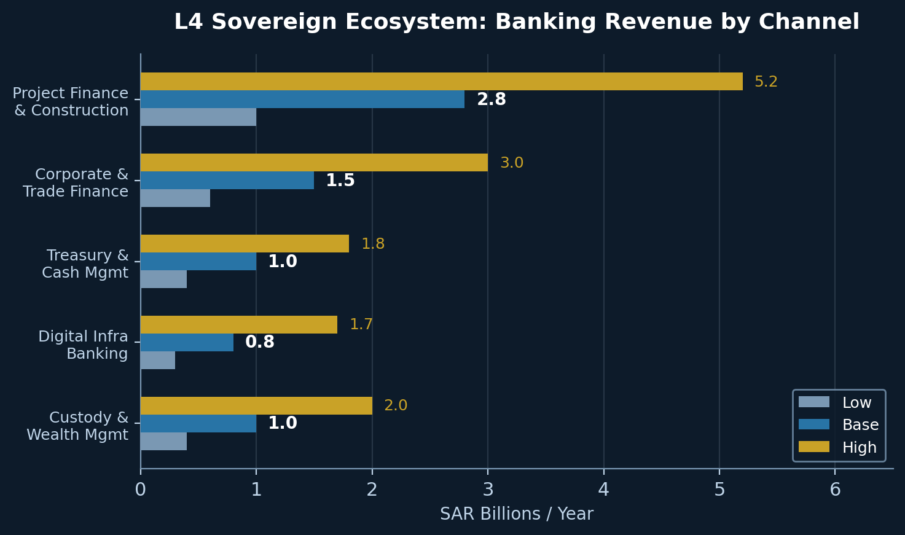

FOUR MOVES // TO CAPTURE SOVEREIGN ECOSYSTEM VALUE
Move 1: Build a sovereign programme coverage team.
Most Saudi banks cover government entities through a relationship manager model. The sovereign AI build demands a cross-functional team that can structure data centre project finance, provide trade finance for GPU imports, offer treasury services for VRP-funded programmes, and advise on IPO readiness for PIF portfolio companies. The bank that organises itself around the sovereign ecosystem as a single client will capture disproportionate share.
Move 2: Invest in AI to serve AI.
Banks that deploy AI internally — credit decisioning, compliance monitoring, fraud detection — are better positioned to serve sovereign entities that are themselves AI-native. SDAIA’s AI Adoption Framework establishes mandatory governance baselines. Banks that meet these standards signal to government clients that they understand the technology, not just the financing.
Move 3: Position for digital infrastructure banking.
Open banking, digital wallets, and API-first platforms are not fintech distractions. They are the plumbing through which sovereign digital economy programmes will flow. Banks that build compliant digital infrastructure now will be the default counterparty when government digital programmes need a banking partner.
Move 4: Prepare for the listing pipeline.
PIF has over 225 portfolio companies. Not all will list, but the pipeline is deep. Banks that build equity capital markets capabilities and pre-position for PIF portfolio company listings will capture origination, underwriting, and custody revenue for a decade.

THE SCOREBOARD // SOVEREIGN ECOSYSTEM LEVER
Low assumes sovereign spending proceeds at reduced pace. Base assumes announced timelines hold. High assumes accelerated build-out with aggressive PIF listing programme.
CHANNEL | LOW | BASE | HIGH
Project finance & construction lending | 1.0 | 2.8 | 5.2
Corporate & trade finance | 0.6 | 1.5 | 3.0
Treasury & cash management | 0.4 | 1.0 | 1.8
Digital infrastructure banking | 0.3 | 0.8 | 1.7
Custody & wealth management | 0.4 | 1.0 | 2.0
TOTAL // SAR B / yr | 2.7 | 7.1 | 13.7

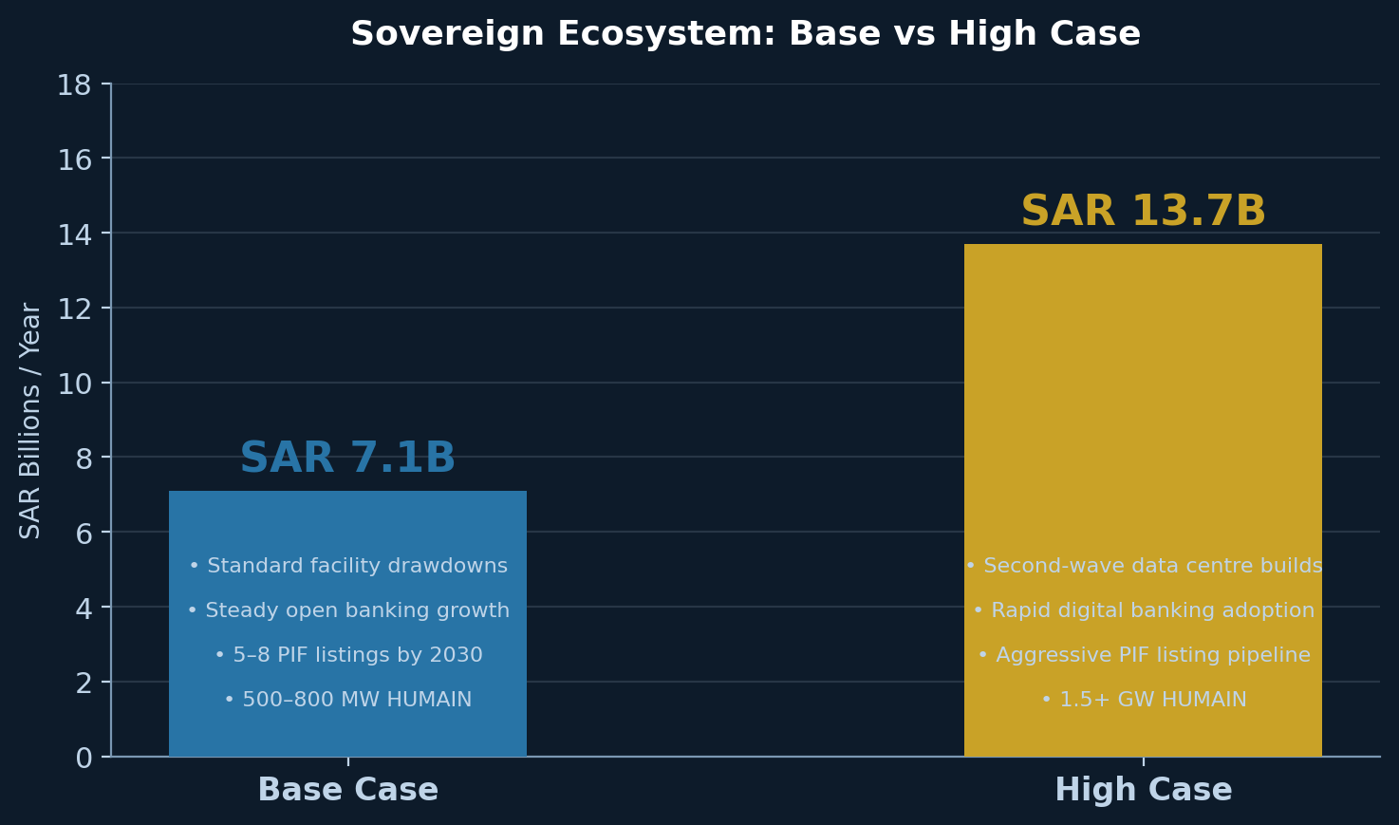

WHAT SEPARATES A BASE CASE BANK FROM A HIGH CASE BANK
A Base case bank services sovereign entities through standard corporate banking products. It wins RFPs. It provides credit facilities. It collects fees.
A High case bank embeds itself in the sovereign ecosystem as an infrastructure partner. It has a dedicated sovereign AI coverage team. It structures data centre project finance. It builds the digital payment rails that VRP-funded programmes will use. It pre-positions for every PIF portfolio company listing.
The difference between SAR 2.7B and SAR 13.7B per year is not whether the sovereign spends. It will. The difference is whether banks position themselves as infrastructure partners to the ecosystem, or remain passive recipients of deposit float and transaction fees.

THE CONNECTION // WHY THIS LEVER POWERS THE OTHERS
The Sovereign Ecosystem lever is the demand engine behind the other three. Lever 1 (Monetization): sovereign-backed digital economy programmes create the customer base for embedded finance, BaaS, and new fee pools. Lever 2 (Tokenization): when the first sovereign sukuk goes on-chain, it will be a government-backed instrument that de-risks the entire asset class. Lever 3 (Capital Efficiency): the more capital banks release through RWA optimisation, the more they can deploy into sovereign ecosystem financing.
The Scoreboard is not four independent levers. It is a system. And the sovereign ecosystem is the engine that creates the demand for all of them.

ONE QUESTION FOR THE BOARDROOM THIS WEEK
Does your bank have a named owner for sovereign ecosystem banking — someone whose job it is to capture the AI infrastructure build as a revenue line?
THE FULL SERIES

01 | Monetization | Growing the top line through fees, data, BaaS and Intelligence-as-a-Service.
02 | Tokenization | Why the first Saudi bank to put sukuk, deposits and real estate on-chain resets the map.
03 | Capital Efficiency | RWA optimisation, Basel IV response and the balance sheet of a 2030 bank.
04 | Sovereign Ecosystem | PIF, HUMAIN, and the demand side of AI. (You are here.)
05 | The Scoreboard | All four levers, three scenarios, one number for the board.

